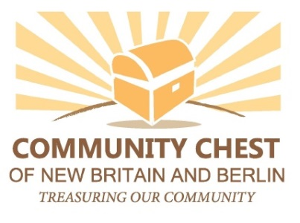
Application date: ____________
Event Specifics:

- Name and address of the organization organizing the event or program:
- Name, email, and phone for contact person:
- Name of event or program, and town where event or program will be held (event must be held in New Britain or Berlin):
- Date and time of the event or program and venue:
- Brief description of event or program:

Budget Information:

- Amount of Community Sponsorship Award requested: $_____
- Has the Community Chest sponsored this event before? If so, how many times?
- How many other sponsors do you anticipate? If you have sponsorship levels, please include them.
- Deadline date for securing sponsors:
- Please attach the budget for the event.

Advertising and Visibility:

- Who is your primary audience? How many people do you expect to attend?
- How do you plan to advertise or market your event or program?
- This is a:
__ One time event
__ Annual event. If so, please indicate how many years running: ______
__ Recurring event, not annual – indicate how often: ______
- How would the sponsorship be recognized? (Please elaborate on any of the below as needed)
_ Community Chest of New Britain and Berlin (CCNBB) logo in printed program (please describe placement)
_ CCNBB logo in paid advertising
_ CCNBB logo in promotional materials (posters, brochure, flyers, postcards)
_ CCNBB banner at event
_ CCNBB speaker at event
_ CCNBB logo on your website publicizing the event
_ Other (Please describe)
For more information or to submit your application,
e-mail CTabone@cfgnb.org

