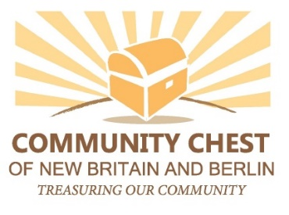

Community Chest of New Britain and Berlin

74A Vine Street New Britain, CT 06052

Phone: 860.229.6018 Fax: 860.225.2666

Grants Guidelines
Known originally as the Community Chest in the 1930s and 1940s and most recently as the United Way of New Britain Berlin, the Community Chest of New Britain and Berlin (CCNBB) is now of the Community Foundation of Greater New Britain. Under this legal structure, a local and independent Board of Directors identify and invest resources in programs and initiatives that benefit the New Britain and Berlin communities.

Areas of Interest and Priorities
The Community Chest will continue its tradition of supporting programs in the health and human service area. It will consider requests for program grants, general operating support and seed grants for new programs. Generally, requests for capital equipment are not funded but may be considered on a case-by-case basis. Proposals will be evaluated with respect to available funding and the potential benefit of the project to the community.

What We Do Not Fund
The CCNBB does not make grants for:
- Sectarian or religious activities Political or lobbying activities
- Deficits Direct support of individuals
- Annual or endowment campaigns Camperships or scholarships for academic
- Sponsorships or fundraisers and/or enrichment programs
- Capital campaigns Performances or one-time events
- Public/independent schools

Eligibility
The Community Chest will make grants to non-profit organizations that have tax-exempt status under Section 501(c)(3) of the IRS Code or that are a qualified entity eligible to receive grants from community foundations under the IRS Code. We will consider funding a grassroots group, if has a governing body and a fiscal agent with the appropriate tax status.

Grant Size
The Community Chest Board of Directors expects to make grants in the $5,000-15,000 range.

Duration of Grants
In general, CCNBB grants are one year in duration. Renewal funding for a multi-year projects will be considered on a case by case basis.

A one-year hiatus is required of a grantee agency after the agency has received three consecutive years of grant awards.

Grant Deadlines
The Community Chest Board meets twice per year to review proposals. The Deadlines for grant applications are April 15 (for the June meeting) and October 15 (for the December meeting).

How Grant Decisions Are Made
When your proposal is received, it will be reviewed and you will be contacted if additional information is necessary. After staff has had the opportunity to study your complete proposal, we may contact you to arrange a conference or site visit. Final grant decisions are made by the Community Chest Board of Directors. Applicants will be notified by mail of grant decisions. If a grant is awarded to your organization, reports on your progress will be expected. Details regarding when these reports are due will be outlined in your grant award letter.

Questions?
If you have questions about your proposal or the application process, please contact Candice Tabone, CFGNB Program Officer - Scholarships & Sponsorships, at 860-229-6018 x302 or via email: ctabone@cfgnb.org.

Application Information
Proposals should be submitted via: https://www.grantinterface.com/Process/Apply?urlkey=cfgnb

